Experiment # 12

**Introduction to Basic Networking Commands and Cisco Packet Tracer**

**Objective:**

* To understand basic networking command.
* Installation of Packet Tracer.
* Establish a connection by using packet tracer and run commands on it.

**Tools:**

* Workbench/Workstation/Software Tools Command Prompt(Run)
* Cisco Packet Tracer

**Commands**

We run different commands to check their working. Type following commands in Command Prompt and check their working accordingly.

* **ipconfig**
* **ipconfig /all**
* **getmac:** to check the mac address of a machine
* **ping:** to check connectivity b/w 2 pc’s either it’s connected on a same network
* **tracert:** to ping a website
* **arp -a:** to check ip address on physical networks on all pc’s
* **nslookup:** to check the domain name

**Theory:**

Cisco Packet Tracer is a network simulation program that allows students to experiment with network behavior. Packet Tracer provides simulation, visualization, authoring, assessment, and collaboration capabilities and facilitates the teaching and learning of complex technology concepts. The current version of Packet Tracer supports an array of simulated Application Layer protocols, as well as basic routing with RIP,OSPF, and EIGRP, to the extents required by the current CCNA curriculum. While Packet Tracer aims to provide a realistic simulation of functional networks, the application itself utilizes only a small number of features found within the actual hardware running a current Cisco IOS version. Thus, Packet Tracer is unsuitable for modeling production networks. With the introduction of version 5.3, several new features were added, including BGP. BGP is not part of the CCNA curriculum, but part of the CCNP curriculum. It can be used to design a network by connecting various networking devices and running various troubleshooting tests to check the connectivity and communication between different networking devices.

Packet Tracer can be used to understand the use of different networking devices

appropriately and the difference in their working. As it is costly to buy various networking equipment while learning networking, Packet Tracer can be used to understand computer networks.

**Procedure:**

**1. Installation:**

First of all install the software by name packet tracer which we use for establishing connections between two or more devices.

**Procedure:**

**1. Interface overview**

The layout of Packet Tracer is divided into several components similar to a photo editor. Match the numbering in the following screenshot with the explanations given after it:

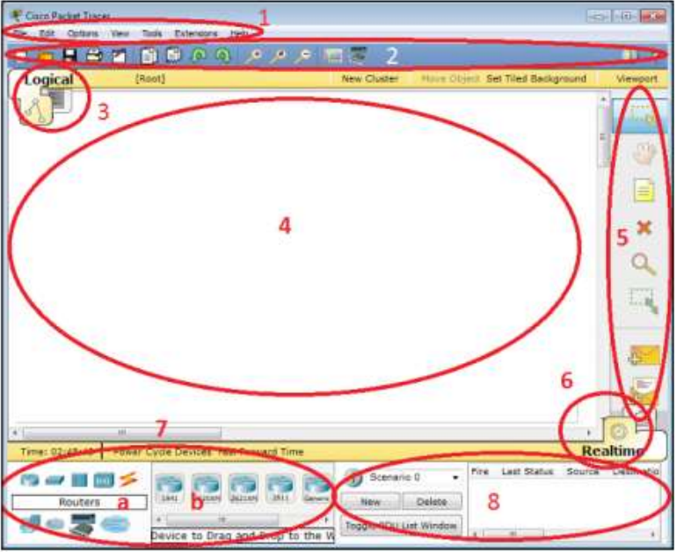

The components of the Packet Tracer interface are as follows:

**Area 1**: Menu bar This is a common menu found in all software applications; it is used to open, save, print, change preferences, and so on.

**Area 2:** Main toolbar This bar provides shortcut icons to menu options that are commonly accessed, such as open, save, zoom, undo, and redo, and on the right-hand side is an icon for entering network information for the current network.

**Area 3:** Logical/Physical workspace tabs These tabs allow you to toggle between the Logical and Physical work areas.

**Area 4:** Workplace - This is the area where topologies are created and simulations are

displayed.

**Area 5:** Common tools bar - This toolbar provides controls for manipulating topologies, such as select, move layout, place note, delete, inspect, resize shape, and add simple/complex PDU.

**Area 6:** Realtime/Simulation tabs - These tabs are used to toggle between the real and simulation modes. Buttons are also provided to control the time, and to capture the packets.

**Area 7:** Network component box - this component contains all of the network and end devices available with Packet Tracer, and is further divided into two areas:

**Area 7a:** Device-type selection box - This area contains device categories

**Area 7b:** Device-specific selection box - When a device category is selected, this selection box displays the different device models within that category

**Area 8:** User-created packet box - Users can create highly-customized packets to test their topology from this area, and the results are displayed as a list. Make sure you are familiar with these names, because moving forward we will be referring to them frequently.

**Creating a simple topology**

Now that you're familiar with the GUI of Packet Tracer, you can create your first network

topology by carrying out the following steps:

* **Step 1.** From the network component box, click on End Devices and drag-and-drop a Generic PC icon and a Generic laptop icon into the Workspace.

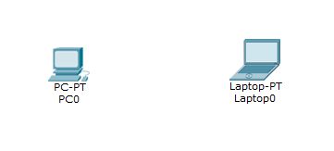

* **Step 2.** Click on Connections, then click on Copper Cross-Over, then on PC0, and select Fast Ethernet. After this, click on Laptop0 and select Fast Ethernet. The link status LED should show up in green, indicating that the link is up.

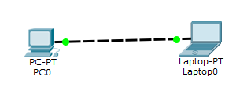

* **Step 3.** Click on the PC, go to the Desktop tab, click on IP Configuration, and enter an IP address and subnet mask. In this topology, the default gateway and DNS server information is not needed, as there are only two end devices in the network.

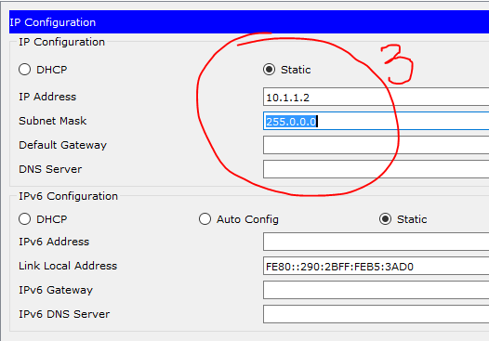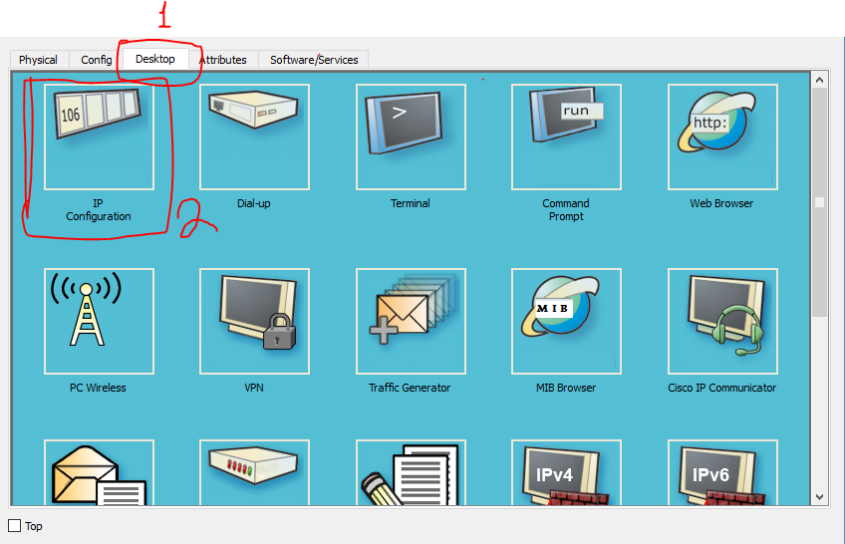

* **Step 4.** Close the window, open the laptop, and assign an IP address to it in the same way. Make sure that both of the IP addresses are in the same subnet. Close the IP Configuration box, open the command prompt, and ping the IP address of the device at the end to check connectivity.

**Building a network having 4 pc’s and a switch and a hub**

Give each PC an IP Address as follow

Host IP Address Subnet Mask

PC0 172.16.1.10 255.255.0.0

PC1 172.16.1.11 255.255.0.0

PC2 172.16.1.12 255.255.0.0

PC3 172.16.1.13 255.255.0.0

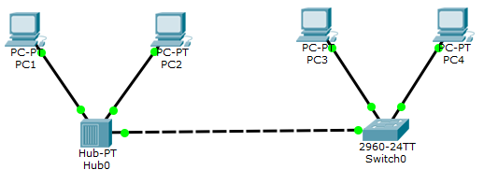

**Lab Tasks**

1. **Explain the output of following commands:**
   1. NS Lookup
   2. NETSTAT
   3. Route
2. **Make a network having 10 pc’s with class A addresses. Use three switches to communication.**
3. **Make a network having 15 pc’s with class C addresses. Use three switches and two hubs to communication.**